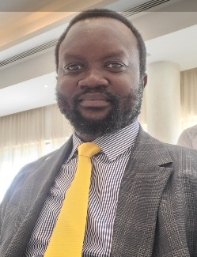**Ador Riak Nyiel**, PhD, is a distinguished academic and a passionate advocate for the right to education for all. He holds a Doctorate Degree in Education (Education in Emergencies) from the University of Nairobi, Kenya, and with prior degrees in; master’s in education in emergency, a Master of Arts in Humanitarian and Conflict Studies, and a bachelor’s in education (English and Literature).

Dr. Nyiel has over 15 years of expertise in policies related to Education in Emergencies, girls’ education, teacher education, education management, youth engagement, and coalition building among Civil Society Organizations (CSOs). He began his teaching career in 2004 but transitioned into humanitarian work in 2014, eventually becoming the National Coordinator for the Partners on Education Group, a civil society network of educators advocating for educational rights.

In 2016, Dr. Nyiel co-founded the National Education Coalition (NEC), a structured network comprising over 180 national and international CSOs focused on educational advocacy. He currently serves as the National Coordinator of this coalition, which is hosted by Oxfam South Sudan. Additionally, Dr. Nyiel is an Assistant Professor of Education at Upper Nile University and actively participates in various educational initiatives, including the Local Education Group and multiple Technical Working Groups established by the Ministry of General Education and Instruction.

Ador Riak Nyiel, PhD

National Coordinator | National Education Coalition

[adorr86@gmail.com](mailto:adorr86@gmail.com) | +211922339780

Juba, Republic of, South Sudan